BA FINE ART

Year 2 Critical Studies and Reflective practice
FA202 Mapping the Mediascape of Contemporary art

MEDIASCAPE ESSAY TITLE PAGE

YOUR NAME: MADELEINE STURGEON-KELL
Murakami and Historical grounding:
To what extent can the work of Takashi Murakami be contextualised by the historical precedents?

ESSAY TITLE:

WORD COUNT: 1998

Founder of the Postmodern Superflat movement, Japanese artist Takashi Murakami (b.1962) is currently at the forefront of contemporary art leaving Japan. Murakami has been the hot name in the contemporary art business of the past 10 years with a wealth of young artists aiming to follow in his footsteps. However, the Superflat movement hasn’t just sprouted from the depths of Murakami’s mind, it was a long process that was informed by a vast history of artists that have come before. From 19th Century painters to cartoon illustrators of the 80s and 90s, this essay aims to breakdown and evaluate the turning point in Murakami’s work to the world-renowned artist we see today.
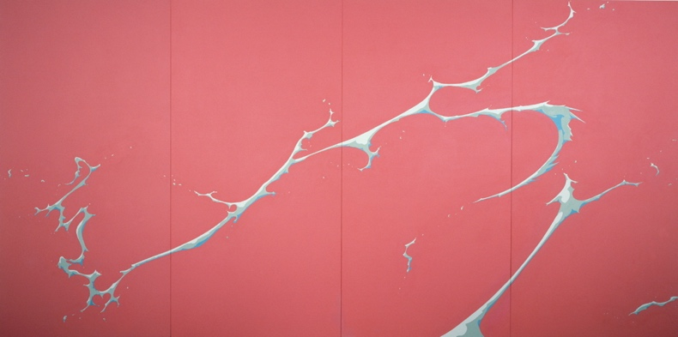
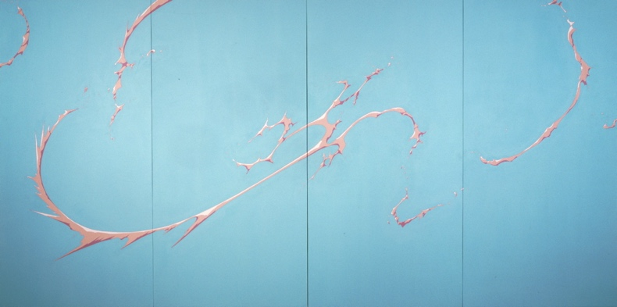
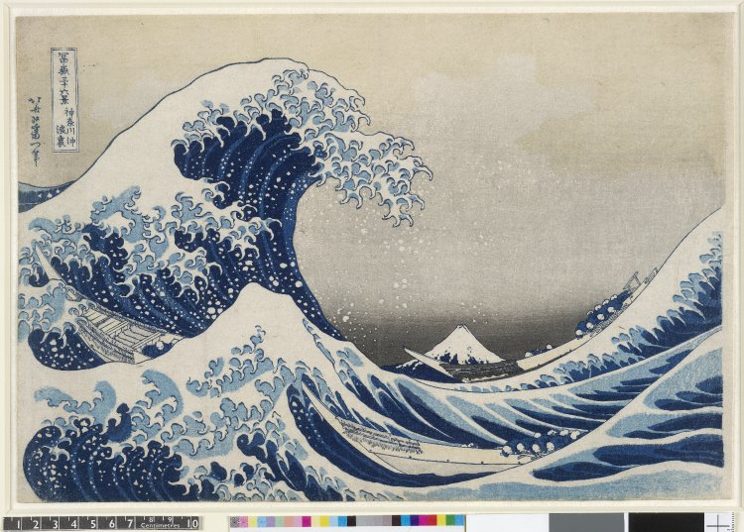
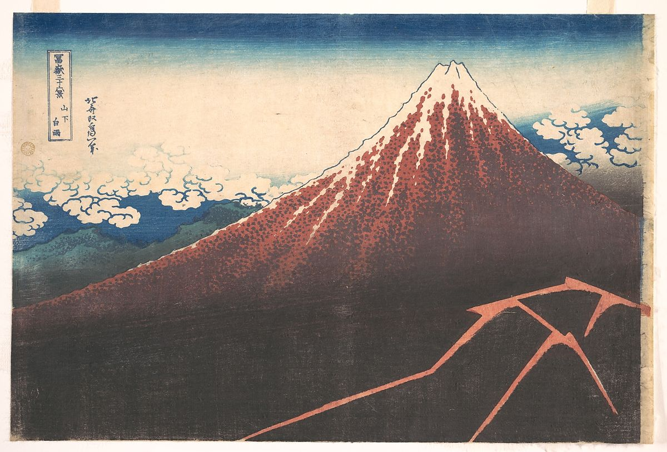
Despite the vast array of work that Takashi Murakami and his factory Kaikai Kiki Co. produce on a yearly basis, one must first consider the beginnings of Murakami as an artist. He considers himself to be a part of a generation who aim to marry traditional Japanese customs with the “overflowing Presence” of foreign culture (Rodrigues Medina, 2009). Thus, as a young man, he studied the practice of Nihonga painting (Japanese traditional painting) in order to develop a technical prowess in technical Japanese art. The art style developed in the late 19th century to early 20th century and it merged western painting techniques with the subject matter and materials of Japanese historical artwork. Initially the similarities between Murakami and the Japanese masters may seem few and far between, but when examining the details of artist Katsushika Hokusai, it can be observed more clearly. The woodblock prints ‘Under the Wave off Kanagawa’ (see Figure 3.) and ‘Storm below Mount Fuji’ (see Figure 4.) are iconic within Japanese art history. A consistent merging of past and present, Japanese and western iconography continually combining was crucial throughout the development of Murakami as an artist. The jagged edges of ‘Milk (Murakami, 1998)’ and ‘Cream (Murakami, 1998)’ combined with the natural fluid flow can be directly sourced to the dramatic wave form and shading in Under the Wave off Kanagawa these jagged forms in Ukiyo-e Kabuki woodblock prints are associated with spirits and ghosts as seen in both Murakami’s work and Storm below Mount Fuji. The water form as a visual aid is seemingly insignificant but “the critical use of a seemingly insignificant element of visual culture… hoisted and transformed to reveal ideological structures.” (Rodriguez Medina, 2009)is crucial to its meaning. The prehistory to Milk and Cream therefore adds to the weighting of the work outside of the apparent superficial flow of the ‘Superflat’ aspect to the work. According to Murakami; “Superflatness is a construction of Japanese culture, as a worldview, to show that it is an original concept that links the past with the present and the future.”, (Murakami, 2000) that is inherently the definition of Murakami’s term ‘Superflat’ as well as a definition of his philosophy as an artist. This determines Murami’s keen eye for unsuspecting symbology and form as a ‘Superflat’ artist and a trained Nihonga painter.
Figure 2.
Figure 1.
Figure 3.

Figure 4.

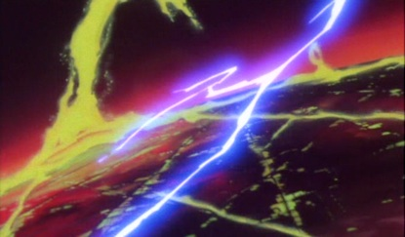
Further developing the highlighted imagery of Milk and Cream and the relationship with 19th century Japanese woodblock prints, the importance of ‘Otaku’, Otaku meaning a person who is obsessed with manga, anime, and other forms of Japanese or East Asian popular culture (Dictionary.com, 2019), and contemporary culture in Japan takes precedence in Murakami’s artwork. The Japanese animator Yoshinori Kanada is somewhat of an idol to the artist and Murakami himself comments on Kanada’s work as resembling “…the compositional dynamic of the eccentric artists…(of the Edo period 1603 – 1868)” (Murakami, 2000) which includes the famed Hokusai as mentioned previously. The animated films Galaxy Express 999 (see Figure 5.) and Return to Galaxy Express 999 (Hayashi, 1979) were among many animated works that played a pivotal role in the creation of Takashi Murakami’s fascination in consumerism and Japanese culture. The inserted still from Galaxy Express 999 depicts the familiar strike form seen in Milk and Cream as well as Storm below Mount Fuji,
Figure 5.

“in which the explosion of a substance whose texture resembles some type of body fluid decoratively traverses the canvas…”. (Darling, 2001)
Kanada’s work was a part of the shunned Otaku subculture, which is often associated with serial killer and necrophile Tsutomu Miyazaki AKA The Otaku Murderer. The otaku subculture is at the heart of Japanese consumerism and the work of Hokusai was once considered the same. Working to expand the consumerist iconography, of contemporary Japan, and controversial subcultures into a global high art market, Murakami is commenting on the “non-adult” (Darling, 2001) child-like imagery that resonates with Japanese media; Kanada being one of many contributing to such a phenomenon. One of the reoccurring themes within Murakami’s body of work is the creation of high art from materialist icons and then the creation of commercial high art, available at a consumerist public level. To further establish a connection between Kanada and Murakami, one must evaluate the materials used by both artists. For the work being commented on, Kanada works in film and hand drawn animation, and in recent years Murakami has begun to develop film-based works. However, the materials that Murakami uses seem to be the cheapest that he can use at a vast commercial scale in his factories, stylistically the links are very much present, but the process of both artists vary dramatically.
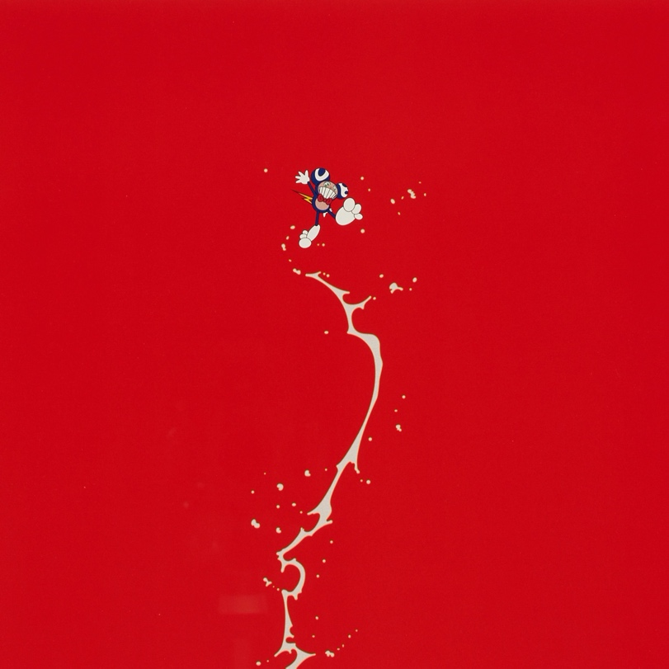

Combining both the form and texture of Milk and Cream and the iconography of the Otaku comes the work Doves and Hawks (Murakami, 2001). (see Figure 6.) Within the familiar “explosion of a substance whose texture resembles some type of body fluid (which) decoratively traverses the canvas…” (Rodriguez Medina, 2009)
sits Murakami’s own mascot Mr. DOB. A key feature of Japanese culture is the constant need for mascots and merchandising, Mr. DOB is the twisted high art equivalent of the Disney mascot Mickey Mouse (Thornton, 2008) and with Mr. DOB as the mascot of the Superflat movement (Rodriguez Medina, 2009) there is some degree of crossover with Warhol’s Monroe as the face of the Pop Art movement. Essentially Murakami is appropriating the ‘public’ image of Mickey Mouse and reproducing him as Mr. DOB, the very same process that defines Pop Art. (Artmovements.co.uk, 2019) This character is acting asthe symbol for the Japanese consumerist machine, with his menacing expression and sinister teeth with the desire to consume. (Rodriguez Medina, 2009)
Figure 6.
“In Japan the display of branded clothing and accessories takes on almost messianic fervour, and has arguably spawned the recent fad of excessive label consciousness among the top-level designers themselves… It is a process one could call superflattening, as the essence of the coveted object…is transformed through hype and consumer demand into a stylized graphic object…” (Darling, 2001)
Despite the polarising nature of Mr. DOB and his occasional manic expressions Murakami’s use for him as an artistic tool is an observational and conversational dialogue on
“the consumerist tendencies of possessiveness and self-oriented lifestyles that emerged during the 1990s…” (Machotka and Cwiertka, 2018) as well as a commentary on the post-war influence of American media (especially Disney) in the 70s and 80s.

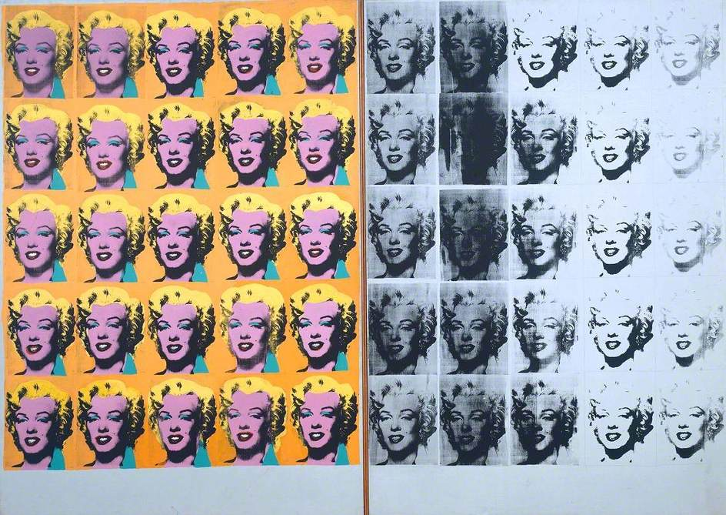
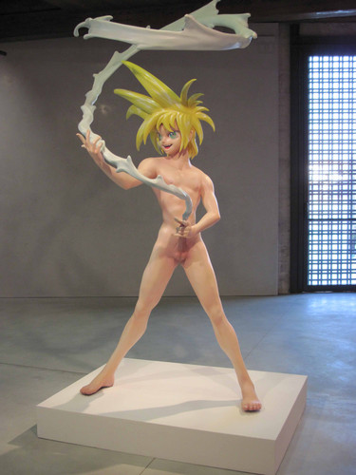
Andy Warhol is a self-confessed idol of Murakami’s and his influence is quite prevalent in the subject matter and theory of Murakami’s Superflat. There are a number of overlapping themes between Murakami and Warhol firstly being that of the production processes and mass scale of production that they both used. Kaikai Kiki Ltd. and Warhol’s Factory are an extension of the artists’ own creativity and in many respects are considered as much of the artists’ handiwork as the work of any other creative. Both artists founded and/or participated in the “Warholism” movement or commercialisation of high art and society, (Ngai, 2005) using consumerist symbols to centre their work around, essentially a Superflat movement of the 1960s. Warhol himself mass produced and profited off of the Coca-Cola and Campbell soup brands as symbols of American post-war society. (Darling, 2001). The soup cans and Coca-Cola bottles have the same weighting in American society as anime and manga does in Japanese post-war society. (Public Delivery, 2018) Building upon this, the use of cartoon sculpture in Murakami’s work ,such as My Lonesome Cowboy (Murakami, 1998) (see Figure 8.) , is a comment on the over-sexualisation of Japanese media much like that of American and celebrity culture as seen in Warhol’s Marilyn Diptych (Warhol, 1962).(see Figure 7.) Furthermore, Mr. DOB is comparable to Warhol’s use of Marilyn Monroe where Mr. DOB is the “postnuclear” (Boyers, 2015) Mickey mouse of Japan and Monroe is the representation of the fetishizing of humans as products in American society. (Public Delivery, 2018) With both artists defacing the society that they replicate in their art. Warhol used the images of Marilyn Monroe even after her controversial death in 1962, much like the use of Otaku themes in Murakami’s work after the Tsutomu Miyazaki murders in the late 1980s.
Figure 7.

Touching further upon the work My Lonesome Cowboy, this superficial over-sexualised child-like sculpture has many other connections to the aforementioned artists. Not only does the work link back to Hokusai but also to both Kanada and Warhol. Beginning with the title, the phrase “Lonesome Cowboy” can be directly connected back to Andy Warhol’s film Lonesome Cowboys (Warhol, 1968). With the film “Originally conceived as a tongue-in-cheek version of the traditional Hollywood western…” (Tate, 2019) it pushes the same “boundaries of what was considered acceptable in…” high art and film (Tate, 2019) as Murakami’s collection of works as a commentary and criticism of the society the artist was raised in. Another feature of My Lonesome Cowboy is the form that it takes as a sculpture. Although none of the aforementioned artists use a significant amount of sculpture, it still resonates as a nod to Anime and Manga merchandise in the format of collectible figurines. Murakami has used the stereotypical human form used Japanese cartoons: big eyes, spiky hair and a slim, sexualised figure which can be said for all of his sculptures with equivalent structure and year. “(He) superimposes opposite ideal(s), the sympathy of childlike imagery and the horror of the creation of contemporary japan…” (Claudine Colin, 2019). The work can be seen in some aspects as an exposé of “the exaggerated over-sexuality of manga characters”. (Rodriguez Medina, 2009) As for the bodily fluid swirling above the boy in the shape of a lasso, it resembles the same form as the flow of fluid across the boards in Milk and Cream as well as the decorative explosions created by Yoshinori Kanada in the films Galaxy Express 999 and Return to Galaxy Express 999. Murakami has merged adult themes and imagery with a simple, seemingly child-like image in order to appropriated Japanese Culture.
Figure 8.

On summary, I believe that most artworks have some form of historical connection and Takashi Murakami is a prime example of that. On first impressions, his work is vastly different from other ‘kitschy’ contemporary artists yet on further inspection, he is linked to artworks vastly different visually but closely linked in theory. Furthermore, the clear evidence that early influences in Murakami’s life had a continual role in the development of new work and continues to do so in his current projects. There are many other areas of Murakami’s work that have arisen from the work of other influential artists that this essay simply could not do justice. The selection of works analysed are limited and organised by their overlapping visual forms but, Murakami has a plethora of work which has many more links to past art history than the ones touched on in this essay. Overall, however, Murakami’s work is built upon a few main themes and features. The history of Japanese creative society and its development into consumerism is key to Murakami’s art combined with the import of western products and societal ideals. These features will most likely continue to play a role in the artist’s future endeavours.

