Richard Prince

Postmodernist appropriative artist Richard Prince has been the topic of discussion and controversy ever since his emergence in the art world in the 1980s when art of this nature was at its height. However, it is not the early work of Richard Prince that intrigues me, it is the 2003-2004 series of ‘Nurse Paintings’ that raise more questions. The collection is vastly more disturbing that the rest of Prince’s practice. They depict eerie and isolated nurses surrounded by heavy washes of colour and, at first, a strangely placed body of text tying the whole image together. It is only upon further inspection and comparison that raises further questions as to why Prince has taken this direction away from his previously photographic based work.
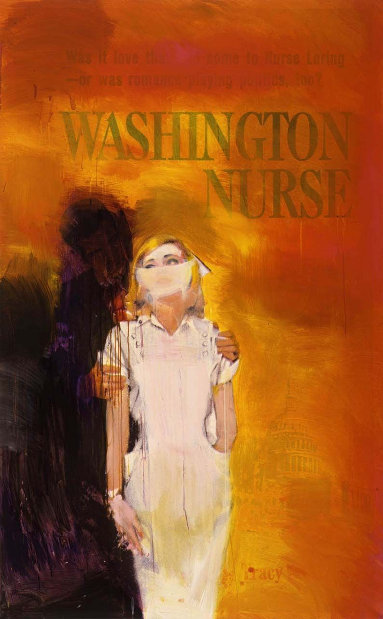
Richard Prince (b. 1949) is a postmodernist artist specialising in repurposing pop culture imagery His work stems from Dada artists like Duchamp to the work of Pop Art founder Andy Warhol. Appropriating art has many definitions, but I feel as it is put most concisely as follows: “(appropriation) Borrows images from popular culture, advertising, the mass media, other artists and elsewhere, and incorporates them into new works of art. Often, the artist’s technical skills are less important than his conceptual ability to place images in different settings and, thereby, change their meaning.” (LANDES, 2000) The key aim and feature of appropriated art is as follows; “… They deconstructed these pictures to reveal their power as signs in the construction of social meaning.” (EVANS, D. 2009). What makes the Nurse paintings stand out from this is their excessive alterations, which is something that you don’t see all too often with an artist like Prince. One of his most notable works is ‘Cowboys’ where he ‘rephotographed’ Marlboro cigarette adverts and displayed them as new work, with no alteration at all. (PRINCE, 1989) Often criticised for the questionable authorship of his work, Prince is always quick to clarify the lack of originality in his art,
Untitled (Cowboy), 1989
Ektacolor photograph
50 x 75 inches
127 x 190.5 cm

“Yes, Appropriation art is a thing. But why does Shepard Fairey get a pass on the Obama "Hope" Poster? What makes Jeff Koons different? Didn't Duchamp already do this with the toilet? What was so great about Andy Warhol's soup can prints?” and he presents a valid point, the purpose of the images is “raw ingredients in the new works was transformative” (MCKENZIE, 2013) These are all key points that Prince continually challenges, but as his work has developed over time, the level of manipulations and alterations has increased almost as though his ability to push boundaries is moving away from authorship and into irony and stereotypes as I will expand upon shortly. But to summarise the apparent intent behind a majority of Richard Prince’s body of work, “In one swift motion, Prince cast doubt on the basic assumptions about the authority of photographic images, the ownership of public images, the nature of invention, and the fixed, identifiable location of the author.” (LEWIS, J., PHILLIPS, L. and PRINCE, R. 1992). The ‘Nurse Paintings’ initially began as a visual statement of the awful things that a person could experience in their lifetime e.g.; cancer, acne, rape which were written alongside the nurse (HIGHSNOBIETY. 2016) as a sort of protective, maternal figure. (PRINCE, R. n.d.)
Washington Nurse, 2002
Acrylic and inkjet on canvas
72 x 45 inches
182.9 x 114.3 cm

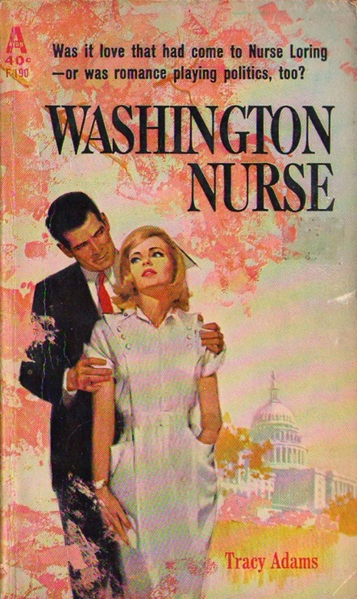
Although the collection creates a completely unique atmosphere to the individual pieces, I must break down the works and focus on the techniques and meaning behind the paintings individually in order to accurately deconstruct them. To begin this process of deconstruction and analysis, I will introduce the ‘Washington Nurse’ (PRINCE, 2002). Firstly, it is quite known that Prince appropriates public images and the chosen appropriated image within this artwork is the book cover of Pulp-Romance novel ‘Washington Nurse” (Adams, 1963). Pulp-Romance novels were short and mass-produced novels often sold at newspaper stands, Prince as a “pop-obsessed… ‘ardent bibliophile’” (SUMMERS, S. 2003) chose these mid -20th century book covers as the centre of his collection. The storyline within the books is mostly irrelevant to the appropriative methods used by Prince, the only criteria being that they were mass-produced images that contained a nurse as the main focus. A majority of the works are imbued with a state of tension, anxiety or even dread. ‘Washington Nurse’ is a perfect example of this heavy atmosphere, with the original male figure mostly disguised, the final work leaves a mysterious looming figure over the nervous and isolated nurse. This positioning and stature of the figures denotes a sense of a harassment, sexual in nature, a theme which is often carried alongside that of female nurses and their association with promiscuity (HOLMES, V. (2012). The role of the nurse in this work is almost angelic yet victimised, she stands in with a defensive stature, shielding herself from the secondary figure. Utilising the nurses as “seductresses of a hypnotically fictional world” almost as pawns in Prince’s “game of irony” (SUMMERS, S. (2003). Furthermore, her mask seems less surgical than perhaps intended, although appearing as a simple stroke of paint, it begins to form into that of a gag, preventing her from speaking out freely. In many ways, this image confronts and portrays many issues that nurses and females may encounter within their professions. It’s not long before one sees the images more as a comment on the flaws in society, reflecting the oppressive attitudes and lack of identity the women often face, further asserting the masks as an aggressive depiction of the silence that nurses must conform to (SUMMERS, S. 2003).
Tracy Adams (1963)
Washington nurse
New York: Avon Books

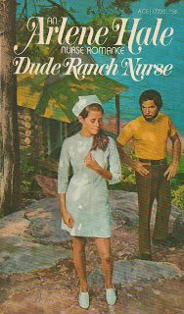
Accompanying our isolated ‘Washington Nurse’ is another lonely figure in ‘Dude Ranch Nurse #2’ (PRINCE, R. 2003). Considering that this image quite clearly depicts the presence of one figure, I will focus more upon the painterly aspect of the piece and how Prince’s manipulations of the image has affected its connotations rather than the subject matter specifically as the series of Nurse paintings have many overlapping themes and imagery. With ‘Dude Ranch Nurse #2’ one can’t help but be drawn to the bold, bloody hue of the red background and dripping brushstrokes. Much like ‘Washington Nurse’, ‘Dude Ranch Nurse #2’ is surrounded by “thick brushstrokes…” however it is just ‘Dude Ranch Nurse #2’ that is embedded with red colour’ “… the disorganised and primary bright red fuses into a darker red creating a sense of chaotic energy and tension that, in combination, pushes viewers to look further to alleviate their discomfort. To add to this discomfort, the bright red is reminiscent of fresh blood, and the darker red is reminiscent of old blood…” (HOLMES, V. 2012) both colours that accompany the nurse in her occupation. The red tones in the piece drip messily down the work, shrouding over her body in some parts, perhaps as a reference to the reliant nature of her patients, or instead maybe a visual representation of emotional weight that the figure is experiencing through the aforementioned pressures and maternal stereotypes that female nurses experience. He is using “regressive nurse iconography…” to generate a shock factor, a certain recurring theme of irony within Prince’s practice, which directly contradicts the current critical issues that nursing suffers in the modern day (SUMMERS, S. 2003). Regardless of the specific purpose of the colour placement, it is clear that it evokes a strong aura of oppression and gore, further pushing the themes of the victim and perpetrator. All of the images are strong to the theme of ghost-like imagery as stated by Douglas Crimp “Prince’s rephotographed photographs… (invade) ‘the ghosts of fiction’” (EVANS, D. 2009). Prince is clearly re-writing the novel from a visual perspective, generating new symbols and characters whilst also directly contradicting the themes of the text within the novel.
Dude Ranch Nurse #2, 2002-2003
Ink jet and acrylic on canvas
70 x 50 inches
177.8 x 127 cm

Although summarising these pieces of artwork after such a brief investigation into them won’t do them justice, it is clear that they have a number of underlying features that make them stand out against Prince’s other work. Overall the work touches upon two main themes, one of which can be applied to that of my own practice within fine art. Firstly, Prince continually introduces the aforementioned “game of irony” in which a vast majority of his work contradicts the message that it is conveying. He consistently challenges the audience with their opinions on stereotypes and cultural taboo whilst addressing them face to face within the visual imagery of each piece. Secondly, and this applies to all of his artworks, he forces all parties to question authorship and authenticity. Although he applies his own touch to every work, with varying noticeability, it is clear that he is using otherwise public images belonging to another author. It is this that I feel should be considered by all artists and visual authors, the concept of ownership is quite fragile, and Prince has provided an excellent example of how to utilise authorship in order to generate new and intriguing artworks.
Arlene Hale
1963
Dude Ranch Nurse
New York: Ace Books

